Heaven’s light is our guide



RAJSHAHI UNIVERSITY OF ENGINEERING & TECHNOLOGY
Department of Mechatronics Engineering

Lab Report

Experiment No.: 07
Experiment Name: Position Control of Servo Motor using Atmega32 with Proteus Simulation.

Submitted By: | Submitted To:
Samia Afsana  ID: 2008055  3rd Year, Odd Semester  Department of Mechatronics Engineering  Rajshahi University of Engineering & Technology, Rajshahi-6204. | Md Mehedi Hasan  Assistant Professor  Department of Mechatronics Engineering  Rajshahi University of Engineering & Technology, Rajshahi-6204.
Md. Sakib Hassan Chowdhury
Lecturer
Department of Mechatronics Engineering
Rajshahi University of Engineering & Technology, Rajshahi-6204.

Date of Experiment: 25th May, 2024
Date of Submission: 1st June, 2024

MTE 3104
Microcontroller and Interfacing Sessional

Experiment No.: 07

Experiment Name: Position Control of Servo Motor using Atmega32 with Proteus Simulation.

Objectives:

- To design a system for position control of a servo motor using the Atmega32 microcontroller.
- To simulate the servo motor control circuit in Proteus software.
- To program the Atmega32 microcontroller to generate the required PWM signals for servo motor control.
- To verify the correct positioning of the servo motor through the simulation.

Theory:

A servomotor (or servo motor or simply servo) is a rotary or linear actuator that allows for precise control of angular or linear position, velocity, and acceleration in a mechanical system. It constitutes part of a servomechanism, and consists of a suitable motor coupled to a sensor for position feedback and a controller (often a dedicated module designed specifically for servomotors). Servomotors are not a specific class of motor, although the term servomotor is often used to refer to a motor suitable for use in a closed-loop control system. Servomotors are used in applications such as robotics, CNC machinery, and automated manufacturing. servomotor is a closed-loop servomechanism that uses position feedback (either linear or rotational position) to control its motion and final position. The input to its control is a signal (either analog or digital) representing the desired position of the output shaft.

The motor is paired with some type of position encoder to provide position feedback (and potentially also speed feedback in more sophisticated designs). The controller compares the measured position with the desired position to generate an error signal, which when fed back causes the motor to rotate in the direction needed to bring the shaft to the desired position. The error signal reduces to zero as the desired position is approached, stopping the motor.

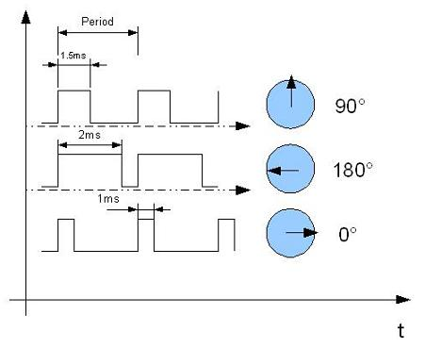
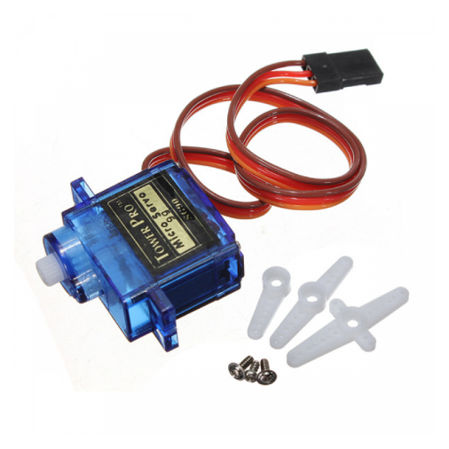

Figure- 7.1: Servo Motor and its position control in different angle [1].
Commonly, servos are electric, hydraulic, or pneumatic. They operate on the principle of negative feedback, where the control input is compared to the actual position of the mechanical system as measured by some type of transducer at the output. The position loop regulates the position of the motor or system. In Position mode control, feedback such as an encoder or resolver ensures that the actual position is equal to the commanded position [2].

This experiment demonstrates the control of a servo motor using an Atmega32 microcontroller. The microcontroller generates PWM signals that control the position of the servo motor. The provided code initializes the microcontroller's PWM functionality and adjusts the duty cycle to move the servo to specific angles.

Working Principle:

- Firstly, PD5 was configured as an output pin to send the PWM signal to the servo motor.
- Timer1 was set up in Fast PWM mode with ICR1 as the TOP value to generate a PWM signal with a 20ms period (50Hz frequency). The prescaler was set to 8.
- The initial pulse width was set to 1.2ms, positioning the servo at approximately 0 degrees.
- The OCR1A was adjusted register changes the pulse width:
  - 600 (0.6ms): ~-90 degrees
  - 900 (0.9ms): ~-45 degrees
  - 1200 (1.2ms): 0 degrees
  - 1500 (1.5ms): +45 degrees
  - 1800 (1.8ms): +90 degrees
- The loop cycles through different pulse widths, causing the servo motor to move to different positions. Each position was held for 2 seconds before moving to the next position.
- The servo motor's shaft position was controlled by the width of the PWM pulse, which was set by the OCR1A register. The changes in OCR1A values result in different pulse widths, thereby moving the servo to the desired angles.

Required Components:
- Atmega32 Microcontroller
- Servo Motor
- Power
- Wire
- Ground
- Resistor
- Capacitor
- Push Button

Code:

#include <avr/io.h>
#include <util/delay.h>

int main(void)
{

DDRD |= 0x20;
ICR1 = 19999;
OCR1A = 1200;
TCNT1 = 0;
TCCR1A = 0x82;
TCCR1B = 0x19;

while (1)
{
OCR1A = 1200;
_delay_ms(2000);

OCR1A = 900;
_delay_ms(2000);

OCR1A = 1200;
_delay_ms(2000);

OCR1A = 600;
_delay_ms(2000);

OCR1A = 900;
_delay_ms(2000);

OCR1A = 1200;
_delay_ms(2000);

OCR1A = 1500;
_delay_ms(2000);

OCR1A = 1800;
_delay_ms(2000);

OCR1A = 1500;
_delay_ms(2000);

}
}

Figures:

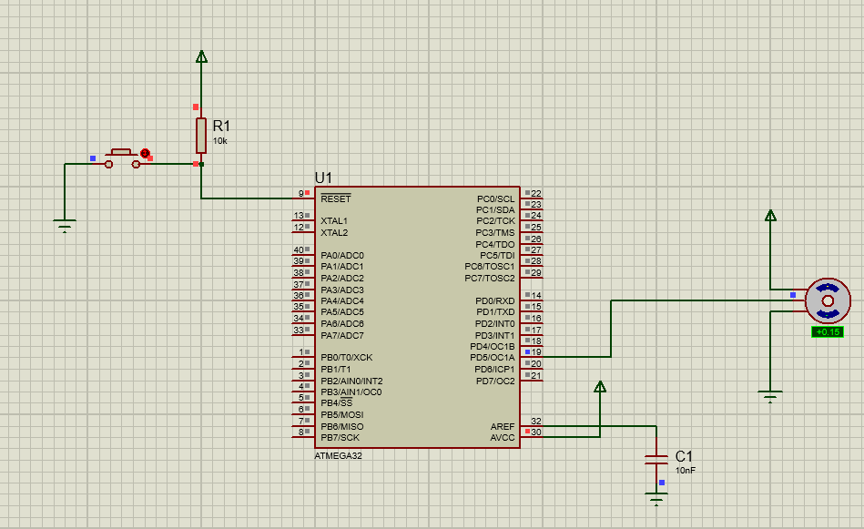

Figure-7.2: Servo Motor position in +0.15degree angle.

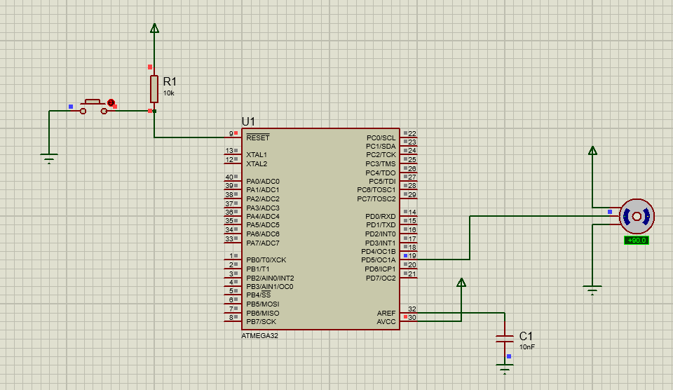

Figure-7.3: Servo Motor position in +90.0degree angle.

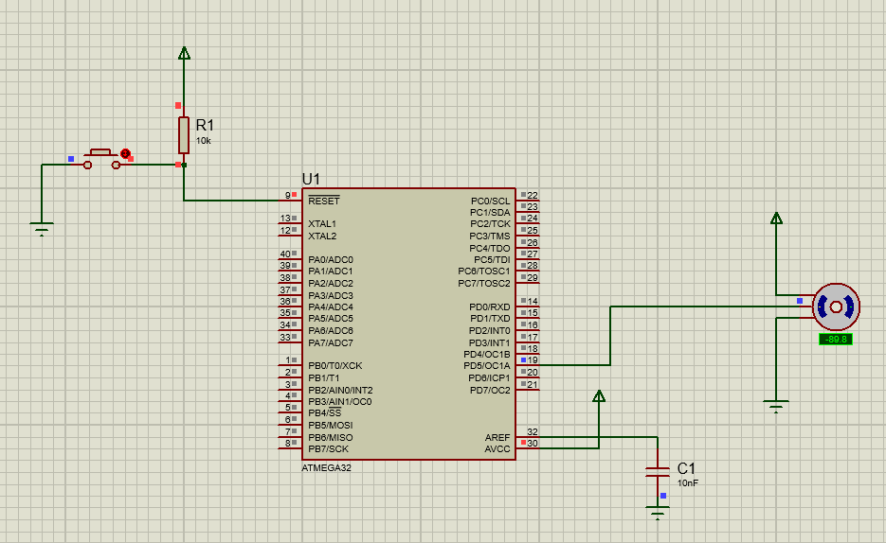

Figure-6.4: Servo Motor position in -89.8degree angle.

Discussion:

During the simulation, the circuit was successfully implemented position control of servo motor using in Proteus software. But the servo motor wasn’t successfully moved to the desired positions as dictated by the PWM signal from the Atmega32. The simulation was failed to validate the correct configuration of Timer1 for PWM generation. The deviation of movement of the servo motor in the simulation was indicated that there had some limitations to achieve proper control and accuracy of the implemented system.

Practical Uses:

- Articulated Robots: Precise positioning of servo motors is essential for controlling the joints and movements of robotic arms, enabling tasks like assembly, painting, and welding.
- Prosthetics and Rehabilitation Devices: Used in artificial limbs and exoskeletons to provide controlled movement and support for patients.
- Industrial Automation: Servo motors are used in CNC machines, conveyor systems, and automated inspection systems where precise control of position and speed is critical.
- Flight Control Systems: Servo motors control the ailerons, elevators, and rudders in aircraft, enabling precise adjustments for stable flight and maneuvering.

Conclusion:
This experiment successfully demonstrated the position control of a servo motor using the Atmega32 microcontroller. The use of PWM signals for controlling the servo was effectively simulated in Proteus, validating the approach. The use of Timer1 in Fast PWM mode provides a reliable method for generating the precise PWM signals required for servo operation. By adjusting the values in the Output Compare Register (OCR1A), we can control the position of the servo motor with high accuracy. This setup can be further extended to real-world applications involving more complex motion control systems.

References:

[1] Position Control of Servo Motor [Online]. Available:
https://www.robotechbd.com/product/motor/servo/servo-motor-sg90/ (2021)

[2] Servo Motor, its Position Control [Online]. Available:
https://en.wikipedia.org/wiki/Servomotor\ (18 May,2024)

